Address:

Date

Planning Applications
North Northamptonshire Council
Thrapston Office
Cedar Drive
Thrapston NN14 4LZ

Planning Application Number: NE/21/00498/FUL. (Further Objections in response to the amendments to the scheme).

I\we strongly OBJECT further to the application above, and all our previous objections still stand.
The latest resubmitted documents:
- Again fail to address previous material objections
- do not comply with National Planning Policy Framework (NPPF 2021),
- continue to include incorrect street names, addresses and inaccurate measurements
- continue to ignore key concerns of residents
- and evidence that Ilke and Coop care little about the law, community cohesion, safety and amenities.
- Ilke keep resubmitting tweaked plans, creating work for residents and council and creating a precedent for development via application.
This development cannot be agreed to on the basis of the current plans, which are disingenuous, inaccurate, have omissions and have so many material objections stacked against them. We are not opposed to development per se, but cannot see how this development can be agreed to with the current flawed designs and the complete disregard for the local community.

The three elements of the NPPF Economic, Social and Environmental are not being met. It appears Ilke’s profit is the only thing being considered. Negative impact to the community economy through mass street parking bans, congestion, impact on people’s daily lives is evidenced. The cost to the community economy is not being factored when this could be offset by creating an entrance via John Clark Way, as highlighted by most of the previous 500+ objections.

Ilke Homes are not meeting social objectives. They are specifically not “fostering well-designed, beautiful and safe places, with accessible services and open spaces that reflect current and future needs and support communities’ health, social and cultural well-being”. Police concerns go un-addressed (i.e. there are still alleyways), open space remains below minimum standards, connectivity to the community is poor, with footpaths blocked and accessible services like bus stops being moved further away.

Ilke Homes are not meeting Environmental objectives, specifically not “– to protect and enhance our natural, built and historic environment; including making effective use of land, improving biodiversity, using natural resources prudently”. They have a biodiversity loss, are proposing cutting down mature trees and corrupting two lovely historic streets’ charm by removing street grass and trees.
Local residents and the wider community will be greatly impacted by these proposals. These plans can not be “Justified”. NPPF p12. Nor are they promoting a “Healthy and Safe Community” NPPF p27.
Specifically further objections cover:
- Construction Environmental Management Plan (CEMP) v.4, dated 11.03.2022
This document highlights the disingenuous nature of ‘consultation’ to date and provides examples of omissions and inaccuracies previously mentioned.
- We note that a final CEMP was available last year (CONSTRUCTION_MANAGEMENT_PLAN_-_AMENDED-527651) v.2 dated 04.03.2021 page 1. There was a further revised edition also dated 15.02.2022. Neither were passed on for consultation, despite major community and town council concerns about relevant matters. This implies that information may have been being withheld from the public. ‘Consultation’ at this stage has included only about 20 houses, so despite this being new information, previous objections will not have had the opportunity to include the CEMP.
- There are many inaccuracies in the document. They do not even get the street names correct, i.e. Prospect Drive? (CEMP P10).
- The documentation has no vehicle tracking used to show how wide loads will be able to navigate narrow and congested streets.
- The traffic management measures are ineffective for 61 weeks of construction (CEMP P9) and will significantly impact upon residents’ peaceful enjoyment and free movement. Using John Clark Way would minimise this.
- They mention 10 Wide loads per install day. They fail to mention ‘abnormal’ loads. Many loads will be at least 6m wide. They need to increase accuracy via detailed provision of load sizes.
- 133 houses with two to three stories (133*2= 266 wide loads – or more) which suggests a minimum of 26 days when complete parking bans will have to be enforced. It may be more days, as plans change. Hence, up to 40 days when cars will not be able to be parked along Northampton Road, Higham High Street, Queensway, Manor Way, The Hedges and part of Prospect Avenue. Wide loads cannot navigate the streets with cars there and residents will not move them voluntarily. This is several hundreds of households to co-ordinate a road parking ban. How can this be done and where will those cars go? None of the affected residents have been consulted about these routes and parking bans.
- Residents have nowhere else to park their cars and no parking areas have been identified.
- Insurance issues (cars need to be overlooked at night) and legal challenges will be made to the council planning department if road closures are granted.
- The cost for Police enforcement should be considered and their detraction from more constructive duties.
- Ilke Homes have still not demonstrated how they expect to travel the extra wide loads along the transport route by issuing a swept path analysis, despite this being raised as an objection following the initial presentation.
- Furthermore, Ilke have still not demonstrated how they expect to get the large cranes onto the site, which shall be required to install the house modules after offloading them from the delivery transport.
- Much of this could be avoided if John Clark Way was used for access.
- The transport routes are wrongly depicted and do not match the words in the routing section. The wording, in CEMP item 4.2, notes travelling along the length of The Hedges, whilst the Routing Plan diagram in appendix B indicates a route along the full length of Handcross Way – are either of these routes actually correct? Has anyone from Ilke journeyed that route with a wide load to assess suitability?
- The traffic management measures in section 5 are indefensible. “Traffic Regulation Orders’ will be sought” from the council.
- CEMP section 5.1, refers to large delivery vehicles using Prospect Avenue as shown in appendix A. However, the drawing in appendix A does NOT include this information. Ilke Homes should clarify if they propose ANY construction traffic to use Prospect Avenue, with swept path analysis being issued to demonstrate how this is to be achieved.
- The S bends in the existing estate have consistent on street parking. Even without this, it is unlikely that that the road widths can support the delivery of large loads, especially abnormal loads. When this is realised, the only course will be to route these wide loads again down Prospect Avenue, destroying trees and requiring residents to curtail their rights to freedom of movement. A basic human right.
- There has been no engagement with the local residents or wider public and it looks like we will be informed and told but have no rights!
- People are being denied the right to undertake development in their own home, i.e. when we can’t put a skip on the road.
- There has been no consideration about how peak road usage from the A45 will be impacted by these wide loads travelling through the day. Has the economic impact to Rushden Lakes been considered here and have they been consulted?
- Section 5.7 and 5.8 discusses traffic marshals and safe working. “In the event of a large delivery/removal, two site members will be appointed as ‘traffic marshals’ to direct the flow of traffic and minimise congestion. During such time, the local residents and local building occupants will be notified of the vehicle movements.” This is for 10 extra wide and/or abnormal vehicles a day at some point and even aside from parking blockages, it is very unrealistic to assume that this will work for such a long stretch of residential streets, especially with just two marshals.
- Section 5.8; “In some instances, it may not be reasonably practicable to achieve physical segregation between pedestrian and vehicle movements. In these circumstances, signallers and safe systems of work should be used to control vehicle and pedestrian movements.” This is a children’s school route and this statement is very concerning. It sounds like not only car parking bans are planned but that we won’t be able to leave our own homes because the footpaths will not be safe. What will happen to people who refuse to move from outside their homes? Are the council going to accept footpath closures over an 18 month period, along this busy route for children going to/from school.
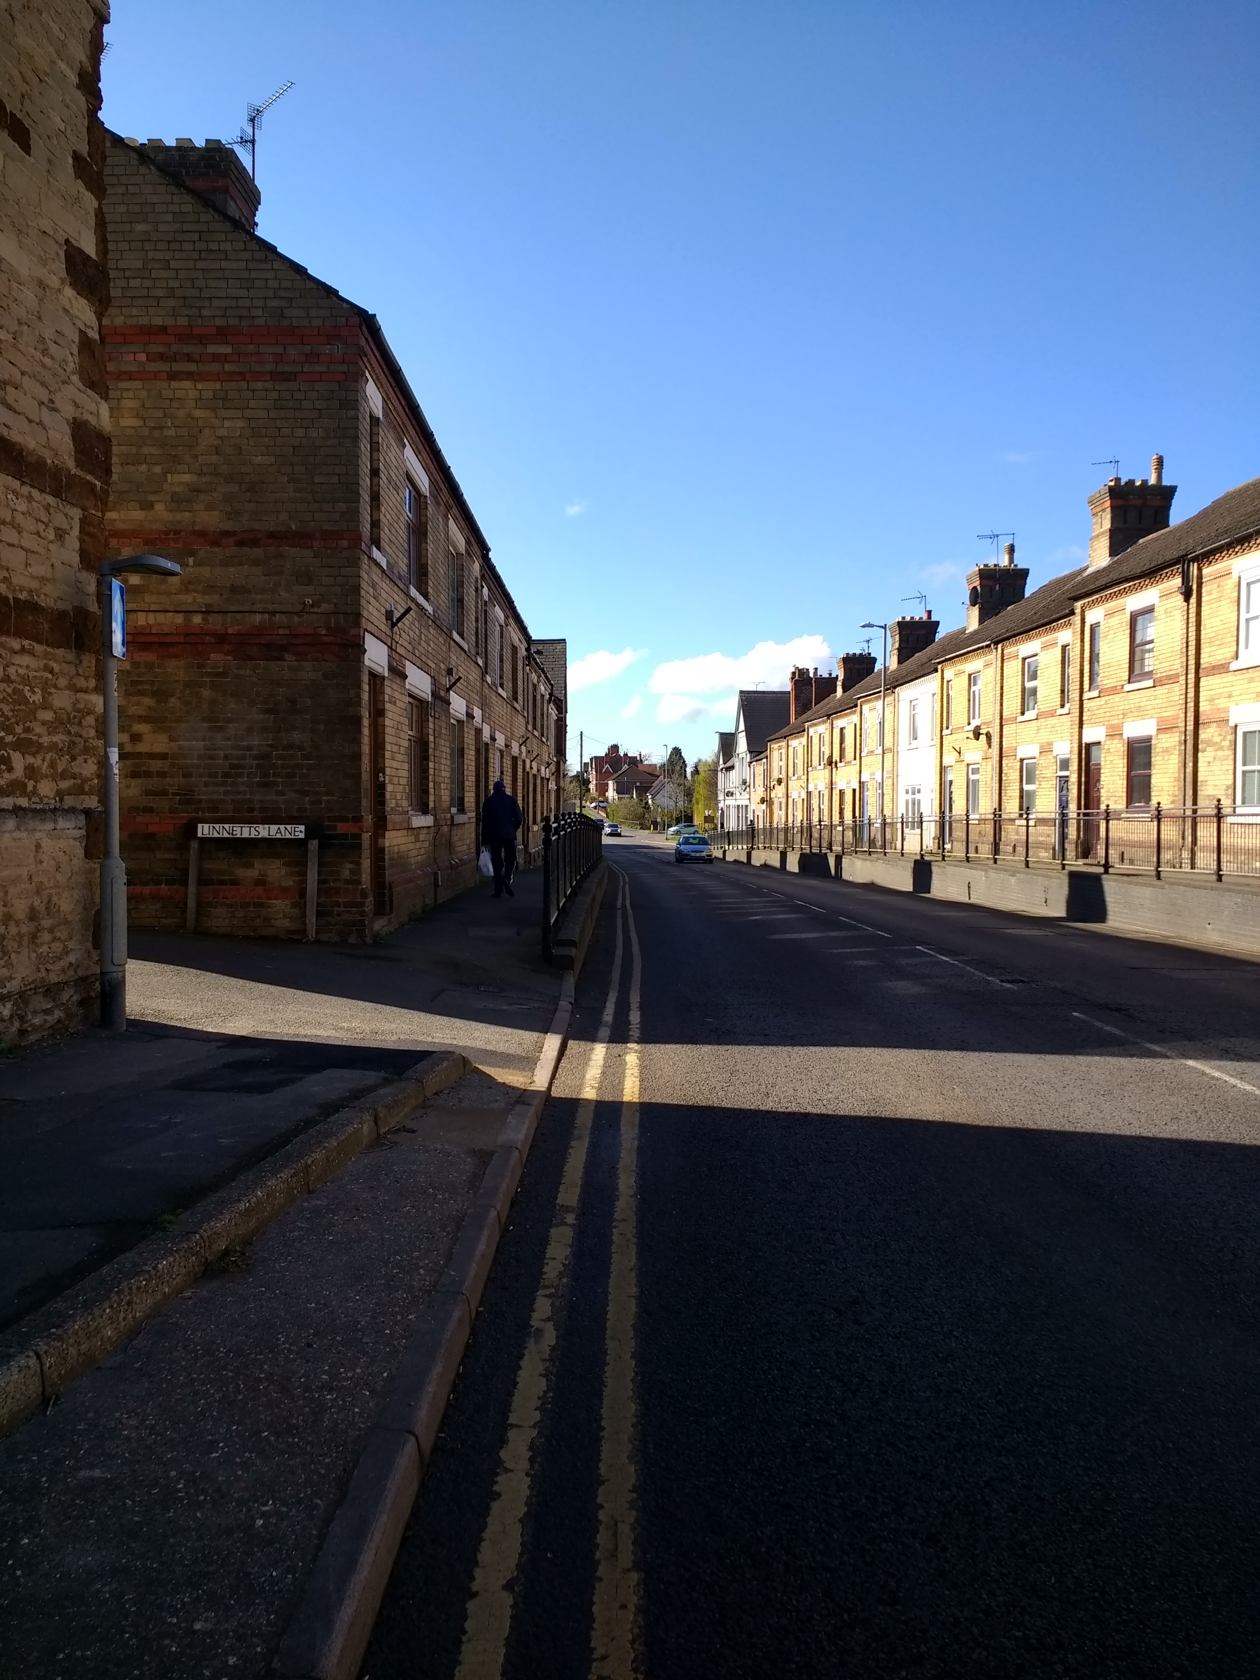
- Section 6.7 indicates that all large delivery vehicles will use the Prospect Avenue road. Large delivery vehicles will not be able to negotiate this narrow and very congested tree lined road. This may be due to a lack of clarity in how the CEMP is written. This needs clarification.
- In addition, the routing plan does not take into account the solid walls built on Higham Rd adjacent to the kerb which will mean it is impossible to use only one side of the street causing complete chaos during the day as wide loads are transported. See Photo.
- A swept path analysis must be submitted for the wide and abnormal loads travelling from the A45 to the site entrance, and on to site, to prove this route is feasible and to confirm what contingency measures may be required.
- The CEMP talks about ‘noise’ during working hours. Many people work from home and the excessive noise from machinery and lorries using residential streets will impact upon this for two years. Again, this would be somewhat mitigated by access via John Clark Way.
- It also includes the transport of ‘hazardous waste’ through residential streets and town centre. Again, this could be avoided with access via John Clark Way.

- Flooding
Ilke Homes have not addressed the potential flooding issues, previously raised by many local residents. There is no mention about putting in the flood defences first given that this is a site prone to flooding.

- Access
3a. Footpath Blockage and Potential Law Infraction
- The junction design, at the site entrance, is not accurate or safe for pedestrians to use.
- It is not clear if the public right of way, to the Greenway will still be accessible.
- It is not clear how the public right of way that crosses the land will be accommodated.
- Both public rights of way have been in use for over 70 years and will be added to the county’s definitive map in May 2022, prior to the commencement of development.
- “Public rights of way (public footpaths, bridleways or restricted byways) are highways protected by law. To divert or close a right of way you must apply for a public path order.”
- Ilke Homes have not applied for any public path orders.
- The CEMP specifically does not mention how footpaths and access to the Greenway will be maintained throughout construction for children and pedestrians to use on the school route.

3b. Junction safety, Bin Lorry Access, Articulated Vehicles and Modular Buildings Transport
- Bin Lorries in (HIGHWAYS_-_AMENDED-527670) overhang the pavement on Prospect Avenue and the central line when performing a right in turn. This will mean that delivery lorries have to do this.
- In the left hand turn they have to use the whole other side of the road which is inherently dangerous to other cars, pedestrians and cyclists.
- The remaining site has no further bin lorry tracking provided, which is problematic as the smaller bin lorries could not get round the site previously. This is surely unacceptable when bin lorries of appropriate length will be overhanging the paths and be unable to get around parked cars?
- It does not appear that they have submitted any tracking for the modular homes being delivered to site, as cars use this corner. Will people will be living on site before all homes have been delivered?
- Specifically Drawing HIGHWAYS_-_AMENDED-527671 (The documentation is highly flawed and shows a disregard for detail and cannot be relied upon.)
- Addresses are incorrect. These are no properties 2&4 The Hedges at this location.
- Removing 10+ parking spaces from the street due to the new junction has not been factored into any of the diagrams. Obviously locals hope this will not happen, but if it is to happen it will impact upon the whole Avenue and create further pinch points
- The drives ways are not laid out like this and so the manoeuvres suggested for ingress and egress are unsafe. Residents have written this on their previous objections, but this has been ignored.
- A minimum visibility splay is being demonstrated as 30m when this should be a minimum of 33m for this type of road. This is against policy and unsafe. There is no mention of any special planning permission being sought to limit the development road speeds to 15mph due to the limitations in visibility.
- The visibility splay past no 71 can not be kept clear and is not entirely within Highways control, as it crosses the boundary of No 71 Prospect Ave.
- 67 & 69s driveways are not represented accurately.
- Looking at the tracking for residents at the site access, the vehicles reversing onto their properties looks dubious with (what’s noted as 2 & 4 The Hedges!) not being able to see down the new estate road as they pull across the road onto the opposite carriageway before reversing.
- This corner has already been the scene of two accidents by Ilke’s contractors and prior to this, the street tree by the turning had to be removed as it had been hit several times by cars and was finished off when a lorry hit it. Two cars can not use this turning at the same time (and it is the same with the turning at the bottom of the Hedges), lorries can not make the turn without using the opposite side of the road and often have to reverse at the junction to get the angle. It will be the scene of many more accidents if this goes ahead. It does not appear that there has been any considered observation of this proposed junction.
- PL04E – proposed boundaries plan:- Suggests that existing boundaries fence should be used. Many fences along PA have suffered as residents have not had access to the rear to maintain, despite Innes Solicitors initially stating that access would be granted for maintenance. This means that some have fallen into disrepair over the last 5 years. Some will also need replacing where alleyways are proposed, as they will need increased height and security features for safety, as the police have already pointed out the evident risks of alleyways. Where alleyways have been proposed, residents have sought legal advice with regard to action that can be taken against Ilke and the council for predictable risk exposure and in the event will resort to appropriate pursuance of action for recompense.

- 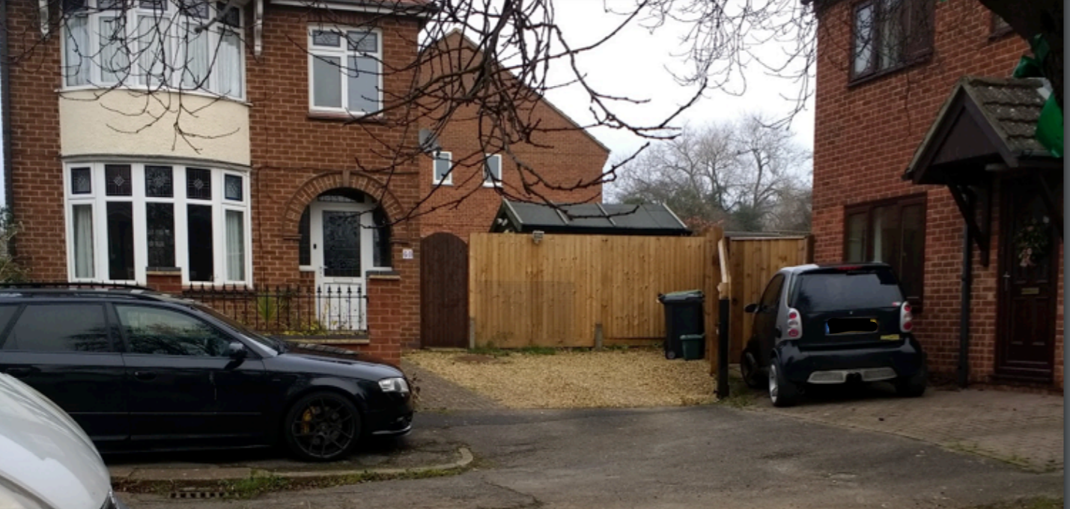

- 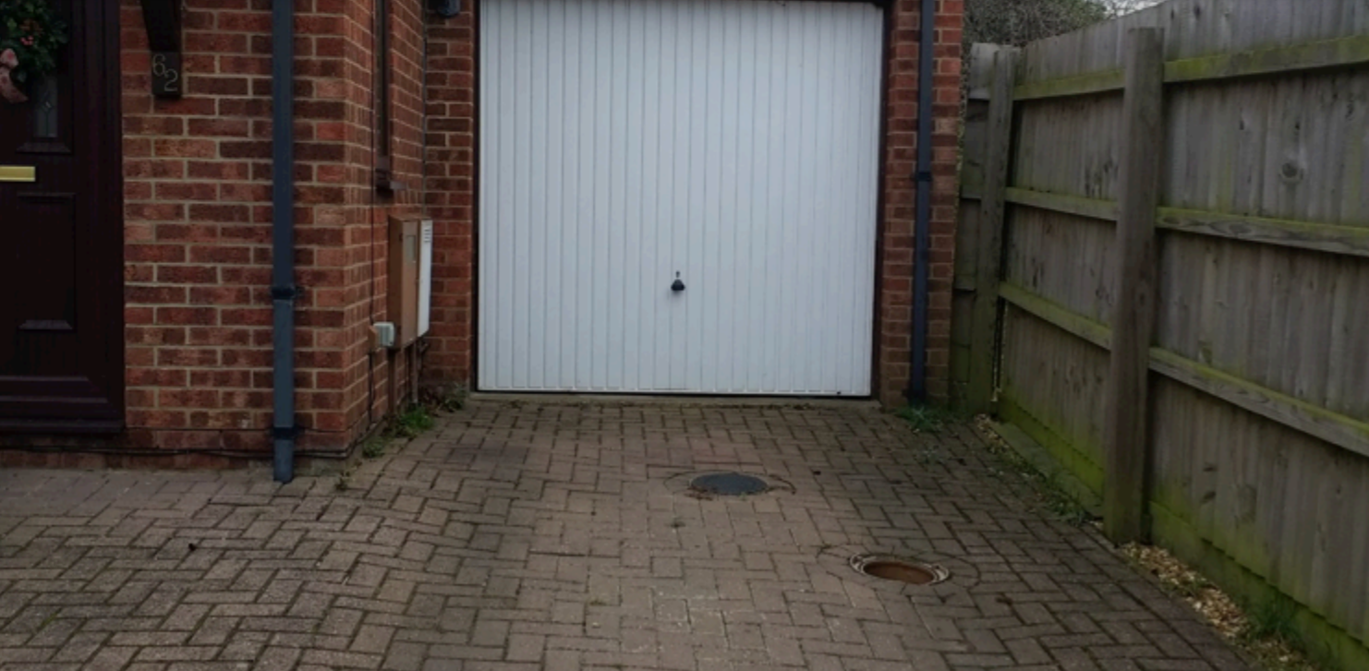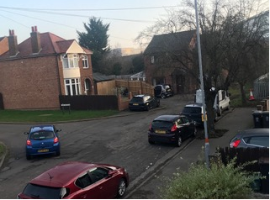
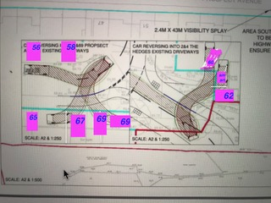

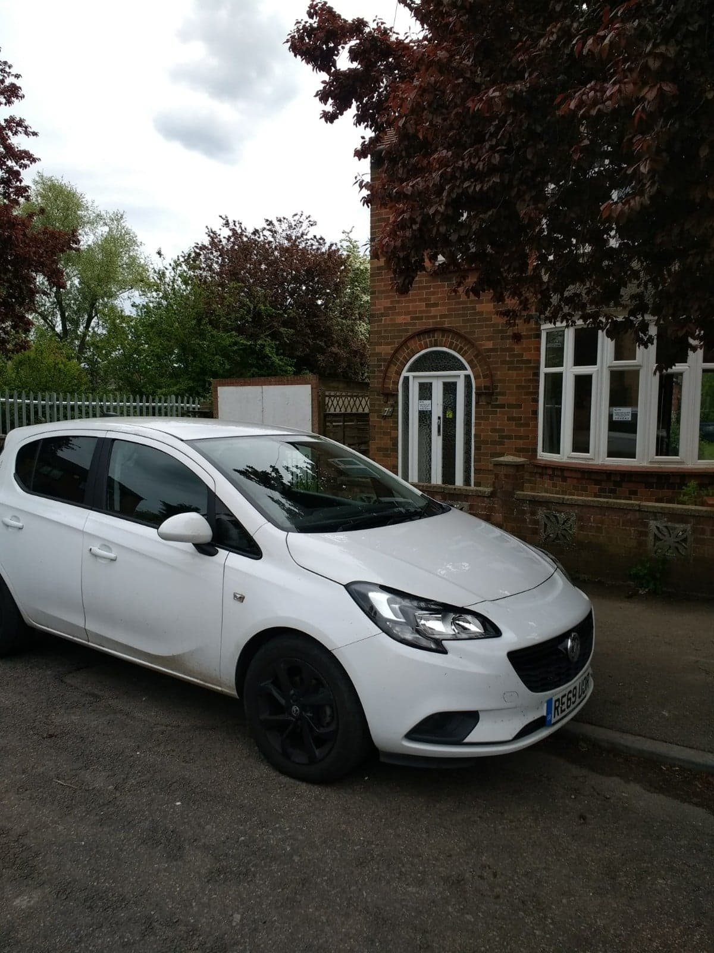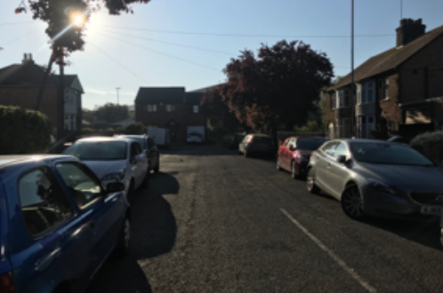

- Further Misrepresentations on the proposal/ need for clarity
- We are particularly concerned that this time (third time of document submittal) Ilke Homes have failed to correct the plan for the junction (drawing number 20241-RLL-20-XX-DR-D-501 Revision D), which contains the wrong street name, the wrong house numbers and the car parking on the driveways are in the wrong position. One house (number 62 Prospect Avenue, but labelled as 4 The Hedges on their drawing) is left with no parking at all. They have put a car in front of the house. At present a smart car parks in that place and that is all that will fit. The main house parking is in front of the garage door, although this is NOT a garage - it is only about 1 metre deep as it has been converted into part of the house. We have provided photos of this. So, 62 Prospect Avenue will be left with no parking at all.
- The driveways of the other houses are misrepresented and placed at the wrong angles, so the turning curves into them are incorrect. Please see that we have rather crudely adapted their drawing to show the correct house numbers and drive-way parking. As you can see, this invalidates their suggestions that this is a safe junction for residents, leaving residents pulling directly onto the junction and leaving one house with no parking.
- It is however a relief to see a diagram includes cars parked near the junction, which highlights that residents on-road parking will not be affected. If this is another inaccuracy and is to change, then this should be incorporated into consultation.
- PL03F – proposed site plan:- Indicates positions of trees in gardens along Prospect Avenue. These are however inaccurate. They have omitted trees from some gardens and placed trees incorrectly in other gardens, e.g. between 57 and 67. This is likely to have an impact on new gardens, given the proximity of new houses to the current boundary where mature trees overhang. There is no indication as to how this will be managed.
- PL04E – proposed boundaries plan:- Suggests that existing boundaries fence should be used. Many fences along PA have suffered as residents have not had access to the rear to maintain, despite Innes Solicitors initially stating that access would be granted for maintenance. This means that some have fallen into disrepair over the last 5 years. Some will also need replacing where alleyways are proposed, as they will need increased height and security features for safety, as the police have already pointed out the evident risks of alleyways. Where alleyways have been proposed, residents have sought legal advice with regard to action that can be taken against Ilke and the council for predictable risk exposure and in the event will resort to appropriate pursuance of action for recompense.
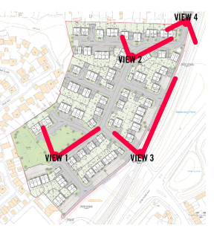
- PL30 E3D site images:- These look very pretty, but lack perspective and are not based in reality. As listed below, the representation of cars (pictures 1-3) is a gross underestimate and also on picture 4 it fails to include a 3 metre drop between the footpath and the railway line. This demonstrates a total disregard for what the situation is currently, at the place of the proposed new junction. It also highlights a total disregard for what will be the actual living conditions for the new residents, who will live with cluttered parking.

- View 1: only 5 cars indicated for 20 houses which is not realistic. This image indicates the only green space on site for 133 homes, which is not very much at all (with exception of flood defence pond behind).

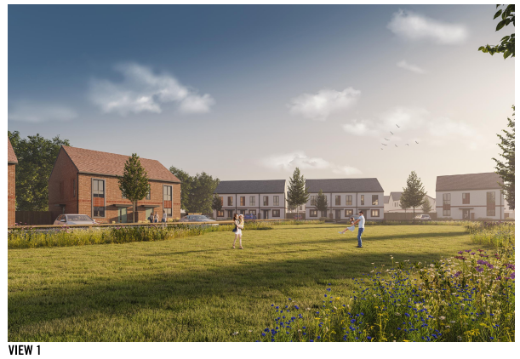

- View 2: only 5 cars indicated for 12 houses which again is not a realistic view.
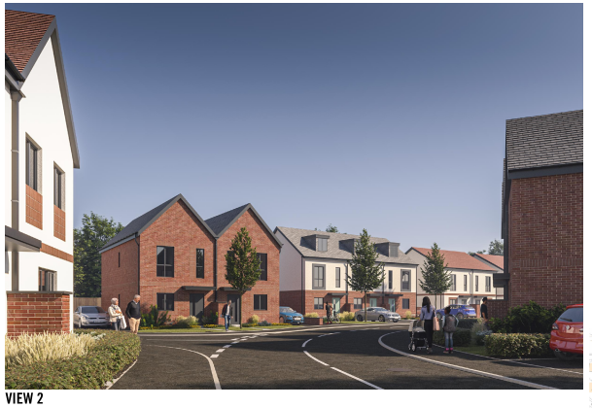

- View 3: An unrealistic 3 cars indicated for 16 houses indicated – This is the logical point of access via JC Way, with a flat good point of access and a potential level crossing.
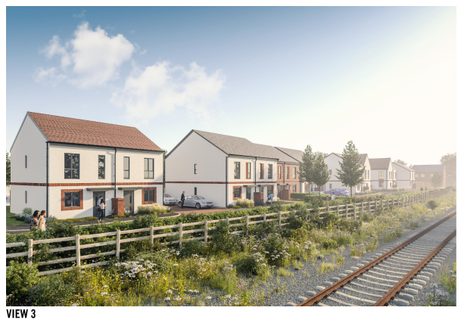

- View 4: The 3m sheer drop between the proposed road level and the railway is not indicated
    - 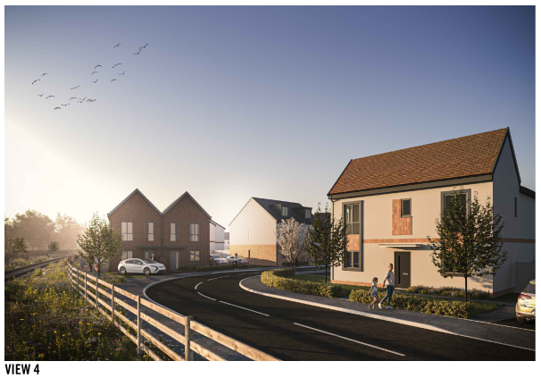

- Higham Road Widening and Turn into Prospect Avenue
- Previous objections and concerns about this junction have not been factored into their amendments. Objections relate to the trees, the personal impact on the adjacent properties and vehicle tracking. Again, there has been no engagement from Ilke Homes with the people of Rushden or Higham Ferrers about this.
- Removal of established street trees is unacceptable to the community and is another biodiversity loss in an area with high levels of air pollution.
- The tree survey only covers 3 trees to be removed on Higham Road and there are 4.
- Two of the trees are downgraded to category B because of unsympathetic maintenance. Are we now paying the price because of cost cutting by the LA?
- The replacement trees to compensate the removal will be planted off site so of no help to the local street scene.
- On the plan they still indicate an alternative bus shelter location as the original position is deemed unsuitable. This could generate more objections from the houses where it would be sited. Have they been consulted?
- Moving the bus stop beside the shop to further up the hill will make it a longer walk for people from the development. Greater than 600m which is against policy.
- The utilities cover noted as relocated is actually a personnel access point to an underground structure for telecommunications equipment. Has the network operator been contacted about the application?
- The vehicle tracking of the amended Higham Road junction looks inadequate with HGV’s having to swing onto the opposite side of the Prospect Avenue to make the turn. If this is the case, when the junction is amended what will it be like when lorries or even standard articulated HGV attempt to use the junction? The tracking appears to only be for a refuse vehicle and the scaling is inaccurate and inconsistent.
- From the vehicle tracking at the site access, they show cars parked partly on the path. Obviously, people do this out of courtesy but the vehicle tracking should assume cars are parked legally fully on the road? Again, if this will lead to removal of parking, the impact on current residents should be considered, as this will create further congestion in the Avenue, which needs to be considered in the traffic surveys.
- Previous traffic surveys lacked accuracy and again were disingenuous, including space between cars as passing points and excluding journey delays caused by lorries. These all need re-doing if parking at either end of the Avenue is to be removed.
- No new refuge point has been suggested to allow people to cross this proposed wide expanse of road with an extra turning lane. Also widening the road as you go into Prospect Avenue will mean further danger for pedestrians as they have a wider expanse of road to cross. Children will be at increased risk as the number of cars turning increases too due to the extra cars from the new development.
- The road widening proposed has already flagged up issues and is against the transport plan.
- Significant costs are proposed to widen a road already a very busy traffic route and it is chaotic when the road has to be closed or single lane for essential maintenance. This is not essential, this is for a building company’s profit. (Access could be from John Clark Way, so as not to impact the community to this extent.)
- There are no detailed drawings for the other road junctions that require to be amended on Higham Road to allow this development to progress and the multiple junctions requiring roadworks will be expensive to people from Rushden and Higham from having delays, as evidenced for the prolonged time period when Northampton Road was made into single lane for another building estate. This makes no sense when John Clark Way can be used without significant costs of time and frustration to the towns, as intended when this land was earmarked for development.
- Street Trees and Neighbourhood Character
- The NNPF p39, states trees should be retained wherever possible. It is possible to retain all the street trees if John Clark Way is used as the point of site access.
- Removal of the trees on Higham Road on the basis that, apparently, they only have 20 years left is unacceptable (TREE_PROTECTION_SURVEY-527663). In fact, the tree Protection Survey (TREE_PROTECTION_SURVEY_-_AMENDED-527665) classifies two trees as Category B with a life expectancy of 20-40 years and two trees as Category C with a life expectancy of 10-20 years.
- These contribute to the character of the neighbourhood and should have a managed end of life with a replanting scheme. E.g., Not just taken out all at the one time. Some of Ilke Homes units only have a life span of 25 years for the roofs and, therefore, the trees would probably still be there after the houses built by Ilke Homes start to have issues and need to be replaced!
- Every tree is precious in an area with the worst air pollution in East Northamptonshire and we object to the removal of these mature trees when additional trees should be planted.
- Planting elsewhere is not good enough when we need improved air quality improvements here.
- The charm and characteristics of Prospect Avenue and Higham Road are an amenity of the local residents, enjoyed by many residents who do not live on the avenue and should not be removed when it’s completely unnecessary. Especially when access should be from John Clark Way.
- Ilke Homes admit the site will bring a biodiversity loss and yet again they plan to chop down more trees for their convenience.
- Ilke are also proposing the removal of Street Grass on Higham Rd which is against policy and the new guidelines. No thought has been given to the biodiversity and environment with this either.

Conclusions
On Monday 4th April 2022, the United Nations released a landmark report calling for a transformation in the way that people use energy, buildings and vehicles. It emphasized the need for accessibility, energy efficiency, outdoor space for exercise and green space for air quality. This proposal breaches all of these priorities. With access via John Clark Way however, and tree-lined wildlife corridors along the north and west sides, the issues of biodiversity, privacy, safety and accessibility would be much resolved. Ironically, this would be a return to the initial plans for this site, from 1996 and the proposals that followed that, where locals were consulted and raised no objections.
Ilke appear to have left provision in case access needs to be acquired via JC Way, which evidences that developers have considered this. There is a ‘turning’ point at the original entry point (opposite Windsor Road), on PL17 E proposed colour site plan. This access was proposed as the ONLY point of entry for this development, when the land was agreed as a building site back in 1996 and has been highlighted in 500 previous objections. Amendment to plots 97, 107 and 108 would enable access via entry from JC way. Further suitability of this is evidenced via view 3 of PL30 E3D.
The current proposals are a retrograde step and would be a devastating blow to the town that would be remembered as a terrible, mistake that could never be undone, hence the public distress that this has caused.
Given the history and the predictability of risks for this junction in particular and also for criminal behaviour, i.e. where there are alleyways, local residents are reviewing legal measures that can be applied to accountable parties, i.e. Ilke and the Council. So when the predictable risk/ negative outcomes eventuate, then responsibility will be applied accordingly.

Thank you again for your time. Please consider the impact of this development on the local community. We hope that your good judgement will take the above issues and all the previous issues and objection in to account. We need our council to protect our community and to ensure the design of safe, pleasing and sustainable places for people to live in.

Kind Regards

